Graph Theory Assignment-3
Roll number: CSB23017
Name: Raktim Ranjan Handique
Session: Spring Year:2025

Objective:
To implement Spanning Tree algorithms for the graph representing road network of Tezpur University.
Used Algorithms :
- Kruskal's Algorithm and (ii) Prim’s Algorithm

Locations :
S : University main Gate
1 : Health Center 2 : KV Central Univeristy
3 : CV Raman Scholar’s Home 4 : Patkai Men’s Hostel
5 : Brahmaputra Boys Hostel 6 : Charaideo Men’s Hostel
7 : Nilachal Men’s Hostel 8 : Kanchenjunga Men’s Hostel
9 : Administrative Block 10 : Student Activity Center
11 : Central Library 12 : KBR Auditorium
13 : Girls Hostels ( BWH + PWH + DWH) 14 : Essential Stores
15 : Girls Hostels ( SWH + KWH + PMCWH) 16 : HSS Building
17 : CSB Hall 18 : Staff Quarters
19 : VC Residence 20 : Guest House
21 : Dept of MBA 22 : School of Engineering

Distances :
14 to 13 : 70m 14 to 8 : 230m
14 to 7 : 210m 14 to 6 : 300m
14 to 4 : 400m 14 to 15 : 80m
14 to 19 : 350m
4 to 5 : 80m 4 to 6 : 180m
4 to 3 : 350m 4 to S : 550m
4 to 10 : 350m S to 2 : 300m
2 to 1 : 100m 2 to 3 : 230m
6 to 7 : 110m 7 to 8 : 210m
10 to 12 : 150m 12 to 15 : 230m
15 to 14 : 210m S to 9 : 220m
9 to 11 : 150m 11 to 16 : 400m
16 to 17 : 110m 16 to 18 : 400m
18 to 19 : 500m 17 to 19 : 400m
19 to 20 : 130m 20 to 21 : 210m
21 to 22 : 300m

Code :
- Kruskal’s Algorithm
edges = [
(14, 13, 70), (14, 8, 230), (14, 7, 210), (14, 6, 300), (14, 4, 400),
(14, 15, 80), (14, 19, 350), (4, 5, 80), (4, 6, 180), (4, 3, 350),
(4, 0, 550), (4, 10, 350), (0, 2, 300), (2, 1, 100), (2, 3, 230),
(6, 7, 110), (7, 8, 210), (10, 12, 150), (12, 15, 230), (0, 9, 220),
(9, 11, 150), (11, 16, 400), (16, 17, 110), (16, 18, 400), (18, 19, 500),
(17, 19, 400), (19, 20, 130), (20, 21, 210), (21, 22, 300)
]

edges.sort(key=lambda x: x[2])
parent = list(range(23))

def find(u):
if parent[u] != u:
parent[u] = find(parent[u])
return parent[u]

mst = []
for u, v, w in edges:
if find(u) != find(v):
parent[find(v)] = find(u)
mst.append((u, v, w))
if len(mst) == 22:
break

for edge in mst:
print(f"{edge[0]} - {edge[1]}: {edge[2]}m")
print("Total:", sum(w for _, _, w in mst), "m")

Output
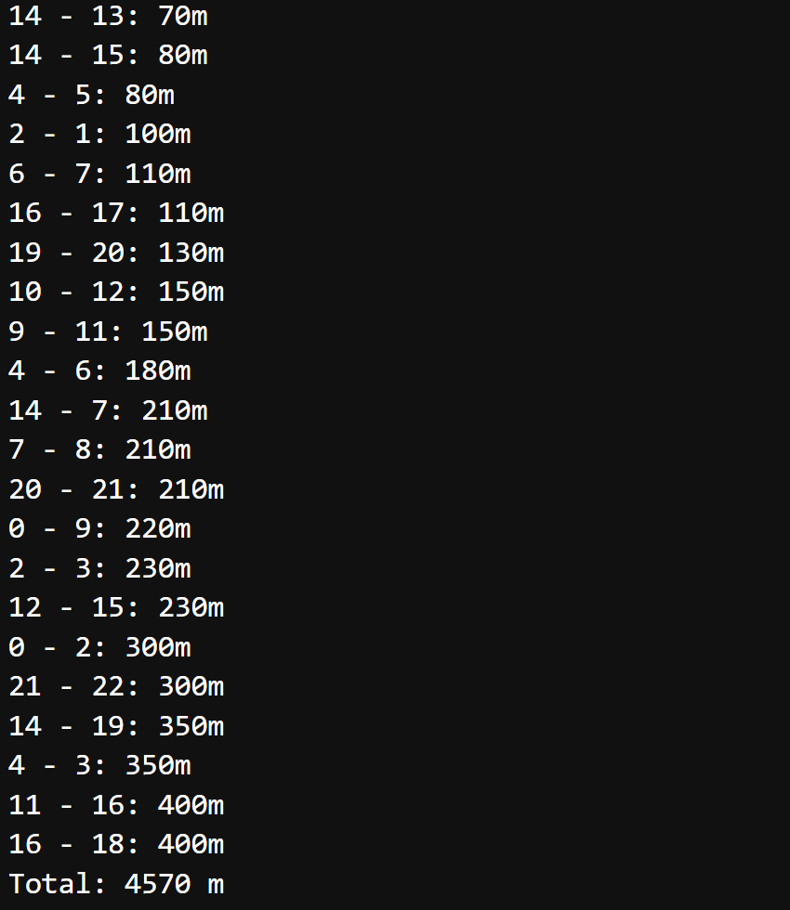

- Prim’s Algorithm

import heapq
edges = [
(14, 13, 70), (14, 8, 230), (14, 7, 210), (14, 6, 300), (14, 4, 400),
(14, 15, 80), (14, 19, 350), (4, 5, 80), (4, 6, 180), (4, 3, 350),
(4, 0, 550), (4, 10, 350), (0, 2, 300), (2, 1, 100), (2, 3, 230),
(6, 7, 110), (7, 8, 210), (10, 12, 150), (12, 15, 230), (0, 9, 220),
(9, 11, 150), (11, 16, 400), (16, 17, 110), (16, 18, 400), (18, 19, 500),
(17, 19, 400), (19, 20, 130), (20, 21, 210), (21, 22, 300)
]

graph = [[] for _ in range(23)]
for u, v, w in edges:
graph[u].append((v, w))
graph[v].append((u, w))

visited = [False] * 23
heap = [(0, 0, -1)]
mst = []

while heap:
w, u, parent = heapq.heappop(heap)
if not visited[u]:
visited[u] = True
if parent != -1:
mst.append((parent, u, w))
for v, edge_w in graph[u]:
if not visited[v]:
heapq.heappush(heap, (edge_w, v, u))

for edge in mst:
print(f"{edge[0]} - {edge[1]}: {edge[2]}m")
print("Total:", sum(e[2] for e in mst), "m")

Output
